Practical - 5

Practical Title: Registration Form with Frontend Validation and User-Friendly Error Handling

Problem Definition: Create a student registration form with HTML5 input types and JavaScript
validation for name, email, mobile number, password, confirm password,
course, year, gender, and terms acceptance. Use Regular Expression for
validations.

Theory:
1. Are correct input types and attributes used?
Yes. HTML5 input types such as text, email, tel, and password are used, along with dropdowns for course and year, radio buttons for gender, and a checkbox for terms acceptance. Attributes such as required, minlength, and maxlength help validate the inputs.
2. Are validation errors displayed near the relevant fields?
Yes. JavaScript displays error messages in red below the respective fields when the user enters invalid information or leaves required fields empty. This helps users identify and correct mistakes easily.
3. Is password strength checked?
Yes. JavaScript uses Regular Expressions to check that the password meets the defined rules, including a minimum length and the presence of letters and numbers. The confirm-password field also checks whether both passwords match. Note: The current implementation validates password rules but does not include a separate visual password-strength meter.
4. Is the form accessible using keyboard and screen-reader-friendly labels?
Yes. Each form field has a corresponding label using the for attribute and matching input id. Appropriate input types, clear error messages, and standard HTML controls improve keyboard navigation and accessibility.

- Implementation/ Output/Result
https://github.com/margiruparel2907-collab/webdev/tree/master/Prac_4

- Evidence of Work (Screenshots)
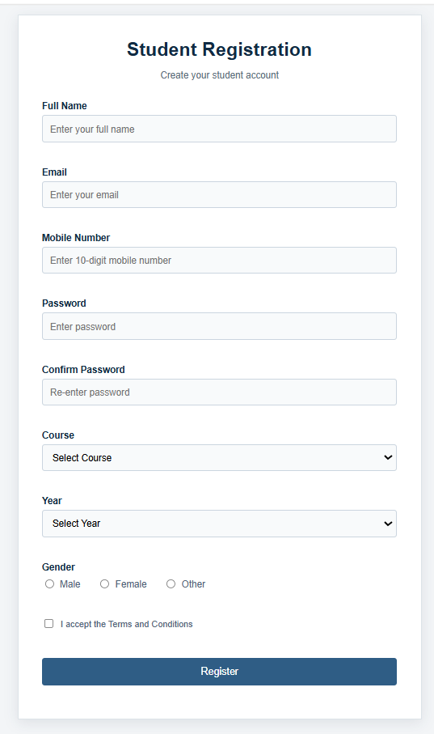

- GitHub Repository Link:
https://github.com/margiruparel2907-collab/webdev

- Challenges Faced:
During the implementation, the main challenges were applying correct validation rules to different fields and ensuring that every input was checked properly. Regular Expressions were used to validate the name, email, mobile number, and password formats. Another challenge was displaying error messages near the relevant fields without disturbing the form layout. Password matching, course and year selection, gender selection, and terms acceptance also required separate validation conditions. These issues were addressed using JavaScript event handling, conditional statements, DOM manipulation, and suitable HTML5 input attributes.
- Learning Outcomes:
Through this practical, I learned how to design student registration forms using HTML5 input types and attributes. I gained experience in JavaScript form validation, Regular Expressions, DOM selection, and event handling. I learned to validate user details, check password requirements, compare passwords, and display clear error messages near the respective fields. I also understood the importance of accessible labels, keyboard-friendly controls, and user-friendly validation in developing reliable web forms.

Faculty Remarks: (Keep this blank for faculty)

